Customer with no incidents (need message)

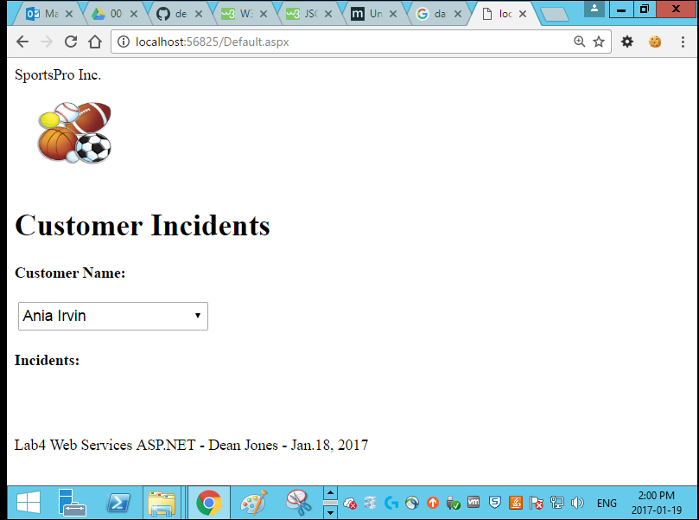

Page Load (message loading NO INCIDENTS)

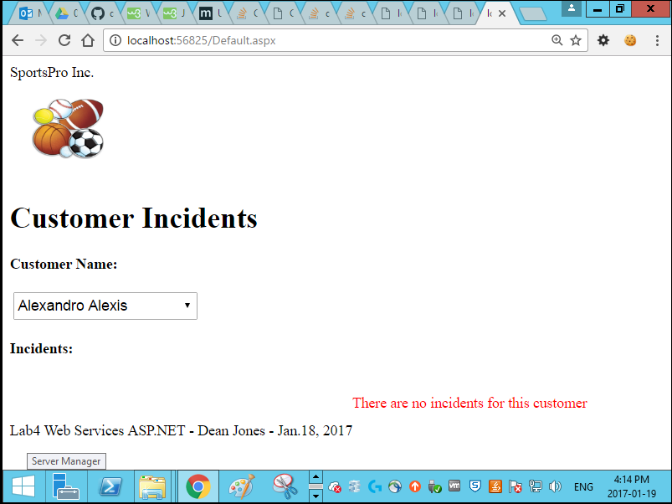

Customer with Incidents (shows incidents) 